Be you.

From The Lost Esoterical Teachings of Jesus

*Remember Who You Are*

**JESUS: TIMELESS LORD**

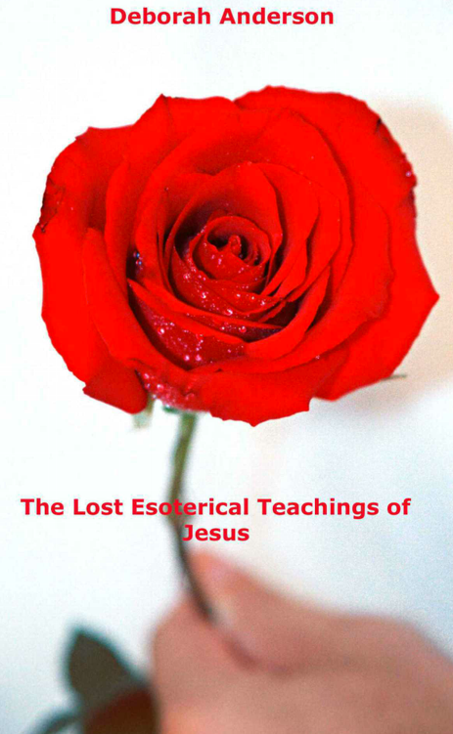Over 2000 years ago, one of the most excellent metaphysical teachers of all time came with an outstanding mission to set mankind free from the greatest lie ever. The lie that man believed about himself. That man believed he was the negative ego imprisoned by negative thoughts and a negative mindset causing him stress, illness, depression, lack of confidence, self-acceptance, inner happiness, inner peace, awareness, self-expression and rise to an understanding of destructive circumstances. And to wake their faith. As King Solomon said in the Old Testament: "Above all things, get understanding."

No longer were the people to be led astray by putting their faith in their leaders. Jesus called this Blind Faith the blind leading the blind. At various times, throughout his mission, he often accused the leaders of being blind guides who used the emotion of fear as a weapon to have power over the masses, making people conform to their will, but calling it “The Will of God”.

His fearless rebuke towards the leaders and his popularity among the people made him extremely unpopular among the religious authorities. Yet, here was a dynamic man who was not afraid to speak up for the people and spoke with unwavering authority words. Jesus came with revolutionary teachings that attracted the crowds in their thousands. His teachings were simple: He exposed the human condition without condemnation and was able to show humanity the way forward. He taught the masses deliverance from the Kingdom of Hell within themselves to the kingdom of Heaven within themselves. Releasing those who were living in the misery of the negative mindset into truth, the reality of

living in the Light. He taught people how to use the power of positive thinking (which was called healing thinking in those days), words, feeling and being. To bring life to their souls and healing to their minds. Bringing humanity back to the Garden of Eden, when man functioned in the higher consciousness of knowing who he was in his true identity. Therefore living in the fourth dimension (The Single Eye of Focus) of ultimate fulfilment where needs and desires are fully met through the right vision, actions, inspiration, intuition, revelation, attraction and right decision making.

**"The Tree of Life"**

Proverbs 13v 12 states, "Hope deferred makes the heart grow sick, but a longing fulfilled is a tree of life".

Jesus came not to create a new religion but a way of life that mankind had experienced before the fall from higher consciousness - positive thinking to negativity. He revealed that mankind was operating under the law of negativity, the law of death in human consciousness, producing negative thoughts, feelings, decisions, and states of being. He told them to crush the enemy of negativity under their feet. Feet being the symbol of understanding. In other words, he told them to crush their negative thoughts - man's enemy within - with understanding. For, as we know, understanding something is having knowledge, and knowledge is power. Once you know something, you can see, for you are no longer in blind ignorance. You will no longer be led astray.

**The Negative Thoughts**

Jesus told the masses that negativity uncontested was like a robber, a liar and a thief to man's soul and mind. He explained that guilt made it impossible for them to enjoy the simple pleasures of life and to attain success for themselves. Thus robbing them of their inner joy and direction. Doubt would rob you of the ability to make the right decision. The decision you know you should take. Thus forcing you to miss your goal in life. Uncontrolled anger. It can scream at you to kill, maim, frighten, and hurt. It is consuming your heart with emotional pain. You forget who you are about yourself. The circle represents the law called karma, and if it's negative, it will have its own law of destruction and illusion. This brings about conflict within man. This has resulted in humanity experiencing the terrors and contradictions inherent in himself and others, causing wars and destruction. Humanity has stepped outside of the bliss that is inherent within itself. Leaving mankind hungry for the fulfilment that it once had. (The Tree of Life the right self-image).

Jesus taught in whatever way he could to reach the people. He used stories and surroundings that people could relate to. Like Shakespeare, his teachings were timeless. But unfortunately, a lot of the teachings of Jesus have been hijacked for the church's prosperity instead of the prosperity of man's soul.

**The Word**

He exposed the human condition so that humanity could know its enemy's thoughts and know-how to deal with them. All the lies, destruction and negative thinking adversely affect health, life and circumstances. Apart from releasing mankind from the law of Karma to a life in the spirit (The Way) with positive thinking, feeling and being, he also taught them the power of The Word, which he called the keys to the Kingdom of Heaven. The Key Words that resonate with your soul and unlock your mind to truth and the realization of who you are in the Light. The very same Key Words automatically lock away illusionist thoughts (Negative thoughts). Thus a man could enter through the door of higher consciousness of knowing who he was with positive thinking and Being. Thereby re-entering the Garden of Eden within. Here man could eat of the Tree of Life again and be filled with joy knowing his Godself within as a provider of goodwill towards him. Jesus taught that God was the giver and the gift. And man, the receiver. Man did not have to earn God's approval by the sweat of the brow. It was a gift. But Jesus taught a method. A law which was a spiritual law of awareness working with higher consciousness. Allowing positive healing ideas to flood conscious thinking and to eliminate all negative thoughts with the Word. The Key Words of Jesus that he called the Keys to the Kingdom of Heaven.

**THE KEY TO YOU**

You have forgotten who you are. You have lower thinking when you think negatively. Eliminate your low self-esteem, your negative ego, your procrastination, your inability to respond to opportunities, and your own denial of your Divine ego and potential.

Remember who you are.

You are wonderful, sensational, dynamic, magnificent, and talented. I dare you to say these things about yourself. Raise yourself up from seeing yourself in the lower self-image to seeing yourself in the higher self-image—the real you.

BEFORE THE FALL OF CONSCIOUSNESS

There were two trees in the garden. As the story goes, one tree was called the tree of life, and the other tree was called the tree of illusion. The trees represented the self-image. So the tree of life represented the Divine image, the true identity of man, the Divine ego, man-made in the image of God. And the other tree represented the false image, the negative illusion - the negative ego. Man was tempted to see himself negatively and when he did, negativity blinded him to his truth about his right Divine self-image. As man's eyes were opened to the negative belief about himself, he found he was naked. No longer clothed in the truth of who he really was.

Before the fall of mankind into negative thinking, Adam (meaning the mind) and Eve (meaning emotion) functioned only in The One Power, the joyous vibration of knowing who they were in right self-image, positive thinking and Being. Otherwise known as the Superconscious Mind, Higher Consciousness, The Light, The Divine Mind, the realm of perfect

ideas, the source of all life and Infinite Intelligence - in a word - God.

Humanity knew only the bliss and ecstasy of living in this positive vibration called the Tree of Life, knowing who they were. Whatever man desired or required was made manifest by the divine provision. The divine provision worked by the spiritual law of awareness working with the Law of Addition - Attraction. Knowing their true identity, the image of the Godself within, or the Light within, as the giver and the gift. And man as the receiver.

The ultimate joy was to know that God was dedicated to fulfilling all of man's needs and desires. So in the Garden, there were no weeds of negative thinking to tend to. However, man was warned that if he ate of the tree of illusion, he would fall and create for himself a false negative image within him. Causing him to see himself negatively, believing he was no good. So he would die within from fear and the self-destruction of wrong thinking.

Why would he die?

Was it a punishment as recorded?

No, it was not a punishment. Once he ate of the tree of illusion, man bit into the belief of seeing himself negatively, causing him to have a negative image of himself. The dark thoughts would then convince him that he was not worthy. That he should fear God (The Light). Doubt would be sown into the mind of man about himself and God within. Thoughts, such as you have done wrong, you are bad, you are guilty, shame on you, God doesn't love you, no one loves you, and God will punish you prevailed, and created in man an I AM bad image. Like the opening of Pandora's box, negative words flooded man's mind like an unwanted torrent holding him captive to their lies and false self-image of himself.

God knew the downward pull of negative thinking and negative self-belief and that if humanity believed in it or bit into it, lies would become truth. Then man would be blinded and cut off from seeing his true state of Being his God-self within - alienating himself from the knowledge of the Supreme Being. Thus causing a void within his soul and cutting himself

off from his Divine provision, positive healing thoughts, feelings, being, ideas, Divine guidance, revelation, inspiration, Divine love, intuition and perfect alignment with the Law of the Universe- the Law of Attraction. God, without, manifests himself as the Gift of positive events, circumstances and material provision.

But as the story goes. Adam ate of the tree of illusion of seeing himself as the negative self-image instead of seeing he was the image of the Divine. Adam then fell into a deep sleep dreaming about his wrong self-image as reality. So man fell into a negative nightmare, and stress, conflict and fear became his God. Fear became a veil within to hide the Light within man of his true identity.

Through the fall man and womankind forgot they were sons and daughters of the Light. Fear blinded humanity, and feelings of despair, murder, homelessness, lack, depression, fulfilment, emotional pain, guilt, shame, self-hate and self-harm were born and cursed mankind ever since. And most importantly, fear of themselves, each other and God.

Live your truth, and you will find your life.

Don't just talk about your truth. Live it, be it.

Your truth begins with you.

To yourself, then be true.

Live your truth