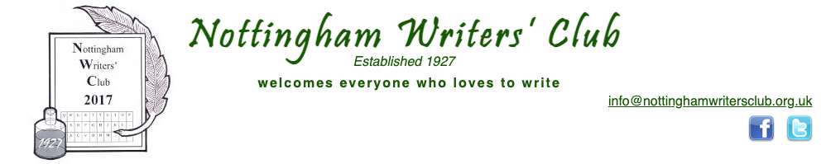

The prose competition is for a story based on a common saying these days, the price of everything but the value of nothing. This is something that definitely affects our modern, throw-away society, and there are a lot of scopes out there for this one when you see how much money is being wasted in lots of situations. The word limit is 1,500.

The poetry competition is 'Bargain', something people love and are all around us. Jumble sales, charity shops, Pound shops, Black Friday, Amazon sales, Christmas sales, etc. Lots of ideas to work on. You can write in any style up to 40 words.

Please send postage stamps to the value of £1.50, but if you live in Nottingham and come to meetings, cash is welcome. We're still considering giving people the option to pay via the website.

This entry from: -

Paul Hickman
Flat 4, Bishop Court
Vicar Lane
Howden
North Humberside.
DN14 7BQ

30th May 2022

Admin@writingthoughts.co.uk

01430 430 493

To: -

Nottingham Writers Club
c/o Mars Hill
29 Redwood Avenue,
Wollaton,
Nottingham,

NG8 2SG

Nottingham Writers Club
c/o Mars Hill
29 Redwood Avenue,
Wollaton,
Nottingham,

NG8 2SG

The Second-Hand priceless Book

A short Story

By

Palbus

The Second-Hand priceless Book

It was pouring with rain on the drabbest day of the holiday so far. We had gone to the shops purely for something to do. The main square in the holiday town had, I suppose, 15 shops or so. Their paint was a bit flaky, and bits of the woodwork had either fallen off or been pulled off by vandals. All in all, the shopping square looked a bit sad and neglected—certainly nothing like the covered all-weather centre near their home. Their centre at home had restaurants, multiple toilets, cafes, and bars. It wasn’t just a collection of ramshackle relics. It was dry, warm, and brilliantly lit and had cost someone a pretty packet. The first-holiday shop they came to was a book shop that sold used and new volumes. The wife and kids decided to go to the ice cream parlour just three doors away. The children had declared that books were old fashioned, and no one read them these days.
John loved old books. There was something about the musty smell of them. The elegance of the type used, and some were works of art. They were cheap enough. He had never given anyone more than £8 for any of the used books that he had bought. He spied a book in a sturdy delivery cardboard box, about A5 size. It had a local address on the address side. The stamp had been removed. Damn, he thought, that might have been worth a bob or two. The box had a brown sticky tape (the type you licked as a kid) going around its girth. Someone (possibly the person that received it) had cut the tape very neatly with a knife to open the package carefully. Obviously, they intended to keep the box looking neat and shipshape. John opened the box, and inside was a leather-bound prayer book with that lovely gold edging on all its pages. How strange, the book looked unread. It was like it had been delivered this morning.
Opposite the publisher's titling page was a handwritten message in fountain pen, ‘To Edith from Tom. Xmas 1941.’ John thought something was missing here, but he couldn’t quite put his finger on it. There was no price on the book. John was intrigued by the book though, and took it to the till. How much is this book? He asked the proprietor. Thirty-Five pounds was the reply. Really! John was amazed, thirty-five pounds for a second-hand book. He set off to put the book back where he had found it.
“It’s brand new, you know.” Said the proprietor.
“Can’t be. It has a message in it saying 1941.”
“It was me that opened the box. Perhaps Edith either never received it or couldn’t be bothered to open it.”
John pondered this for a small while. “Why thirty-five pounds?”
“It’s a rare double volume. Two books in one. The sort of thing that a Vicar would have used. Not a layperson. Quality as well, leather-bound. It’s been in its box all this time, and the leather is like new.”
John had to admit that the book was in first-class condition and was a quality edition.
“The modern edition of that book costs sixty-five pounds, you know.”
“No, I didn’t. So it is looking almost like a bargain.”
“That book is purely based on King James Bible text. It’s old-fashioned English with a real and permanent feel to it. Nothing Americanised about it at all.”
John was very tempted to pay the price for the book. That missing something from earlier on was still troubling him. He heard himself say, “Did you know Edith?”
The old man on the till showed visible hesitation in answering. “Yes. She was my mother.”
“and Tom?”
A tear rolled down the cheek of the man on the till.
“Why are you selling the book?”
“My mother died, and I was left it in her possessions.”
“Do you not want to keep it?”
“Tom never came back. Tom is my Dad.”
“Ah, the war.”
“No. He just never came back. Left Mum and me to it. Ran off with Maureen.”
“I am sorry, I had no idea. War years, rationing, no income, must have been very hard.”
“Worse, Maureen was my Mum’s younger sister. My aunty.”
John had this quick thought. He knew what was missing. There were no kisses. The message was so cold. “When did Tom leave you both?”
“Christmas 1941. Now we both know why Mum never bothered to open that Christmas present that came through the door on December 17th 1941. That book was abandoned just like she was.”
John took out his bank card and offered it to the shopkeeper. The book was wrapped up and put into a fancy bag which had an advert for the shop printed on it.
“Thank you.” was all John had said further before leaving the shop. Books are just books. He had never chatted to a vendor quite like that before. That never happened in their swanky new centre.
The ice cream was superb. It was made on the premises, with so many different flavours.
The takeaway fish and chips were just mouth-watering.
The sun came out, and they headed for the beach.
“You were in that book shop for a long time!” said his wife. “You must have found something exciting.”
“Yes. An old prayer book. Very rare. 1941 and never been out of its box.”
“You don’t go to church.”
“I never travelled on the Titanic either but have loads of books about her.”
“An ill-fated old lady to have been lost on her first outing.”
“You don’t know how profound what you said just is. Edith. I will tell you all about her later.”
The book became a memory of a rainy day on holiday in… John had forgotten where they had gone. He probably never went back again. So, the book sat on a shelf unread for many years. Unread by its recipients. BUT dearly loved by both its new and its previous owner.
That book was priceless.

The End.

